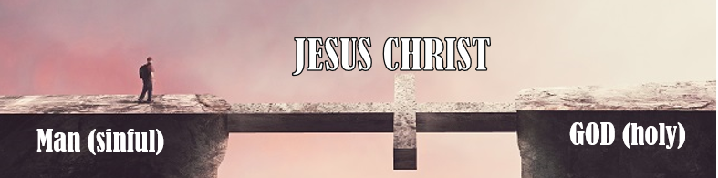

Lesson 1

Dear friend,

Welcome to the third Bible course! I am glad you want to learn more about God and His Word!

In our first course, we have considered some of the basics of the Christian faith. Now, we want to focus on the great salvation God offers to every human being on earth.

We want to have a look at…

… why we have to get saved,

… how we can get saved,

… the question whether salvation is forever.

I hope you are saved; if not, you will get saved! The Bible repeatedly states that we must make that decision before we die! You will decide where to spend your eternal future – in heaven or hell. Do you want to find out how this decision should be made?

**CONVERSION AND GETTING SAVED**

1. Who is a Christian? Tick the boxes with the correct answers. If you find another answer, you can also write it down.

A Christian is someone who…

lives in a Christian country

was baptized as a child

lives a good, orderly life

reads the Bible regularly

is raised in a Christian home

is serious about his religion

goes to church every Sunday

has decided to follow Jesus Christ

prays before he eats his meal

tries to help others in need

__________________________

__________________________

1. The believers in Antioch were first called Christians (Acts 11:26). What made them Christians?

**Acts 11:20+21**

____________________________________________________________________________________________________________________________________________________________________

__________________________________________________________________________________

1. Jesus claims that not every person who behaves like a Christian (for example, by following most of the aspects from the list above) is saved. According to His teachings, what are the features of mere professors (those who say they belong to Christ, but they don't) and those who are Christians?

**Matthew 7:21; Mark 7:7**

* professor: ____________________________________________________________
* Real believer: __________________________________________________________

The Bible says that a Christian is someone who has accepted Jesus Christ as Lord and Savior through faith. Jesus criticizes those who call themselves Christians without having a personal relationship with Jesus Christ. Only those who convert to the Lord Jesus are true believers.

1. What does conversion mean?

**Acts 26:17.18, 1Thessalonians 1:9**

____________________________________________________________________________________________________________________________________________________________________

__________________________________________________________________________________

Conversion means changing FROM something (by turning away) TO something (by turning to). If a person wants to turn TO God, what do they have to turn away FROM?

* sinful life
* life without God
* religions and their idols
* self-righteous attitude
* effort to please God by doing good works

The Parable of the Lost Son illustrates conversion well (you can find it in **Luke 15:11-24**). Verse 18 says that the Son wanted to arise and go to his father (and thus leave the place where he was). This included a complete change of mind and a trustful and repentant return.

1. The necessity of man turning to God: Why do we need conversion?
2. Why do you need to convert to get saved?

**Romans 3:10-12+23; 1 John 1:8**

____________________________________________________________________________________________________________________________________________________________________

1. Maybe you say: "Well, I may have done something bad, but I have not sinned against every law." What is God's answer?

**James 2:10**

____________________________________________________________________________________________________________________________________________________________________

1. Maybe you say: “Well, I may have lied. But I have never committed adultery or murdered somebody, as the law forbids.” What is the answer of the Lord Jesus?

**Matthew 5:21+22; Matthew 5:27+28**

____________________________________________________________________________________________________________________________________________________________________

1. What else (besides doing, saying, or thinking something wrong or evil) is considered a sin?

**James 4:17**

____________________________________________________________________________________________________________________________________________________________________

Are you also a sinner (tick your answer)?

No 🡪. Then check your life before God as you apply the Ten Commandments (Exodus 20)

to you (for example, "You shall not lie," "You shall not steal," "You shall not envy," "You

shall not have other gods”, “You shall honor your father or mother,"…). Do you know

you are a sinner?

Yes 🡪 Now, you can move on to the next question.

The Lord Jesus once said: “They that are whole have no need of the physician, but they that are sick: I came not to call the righteous, but sinners to repentance" (Mark 2:17). He compares sin to an illness that every human being is afflicted with. Like only those who will consult a physician when they realize they have a disease, only those who accept they are sinners can get saved. The Lord Jesus didn't talk about righteous men here (since there are no sinless, righteous persons) but about those who only consider themselves perfect. They cannot get saved as they will never "consult" Jesus. Thus, it is essential to realize that one is a sinner!

1. We have read that all men are sinners. What is sin?

**1. John 3:4**

______________________________________________________________________________________________________________________________________________________________________________________________________________________________________________________

1. The Bible says that all human beings are sinners. That is, in fact, undeniable if we see our own lives. But are we even born as sinners, or do we turn to sinners at some point?

**Romans 5:12.19; 1. Corinthians 15:22**

____________________________________________________________________________________________________________________________________________________________________

1. This seems to be a harsh consequence we have to face. Even though we don’t have any right to question God and His sense of justice, the Bible repeatedly says that God’s judgment on sin is faithful and righteous (Revelation 16:7). Why is sin such a bad thing in God's eyes?

**Genesis 6:5+6; Isaiah 43:24**

____________________________________________________________________________________________________________________________________________________________________

We have seen that sin is an awful sin for God because by sinning, we deny the existence of a great God and Creator, whom we, as his creation, have to obey. Sin is an expression of arrogance, rebellion, and revolt against God.

1. How does sin affect the relationship between man and God?

**Habakkuk 1:13; Isaiah 59:1.2**

____________________________________________________________________________________________________________________________________________________________________

God is too holy to accept anything evil and sinful in his presence. Imagine a wonderful, shining, glamorous palace with marble and a precious red carpet. Now, a dirty pig runs into this palace and gets everything filthy with its muddy claws. Does the pig belong to this glamorous area? No! That's the same with us: We made God's wonderful creation dirty by committing our sins, by lying, stealing, and murdering. This is an unacceptable insult to God he can not accept! Therefore, it is true and righteous that He has to cast sinners into hell. His wrath upon sin (Romans 1:18) is just!

1. If God hates sin as much and has to punish sinners – why and how is it even possible to get saved from sin?

**1 Peter 2:24; 1 Peter 3:18; Isaiah 53:5**

______________________________________________________________________________________________________________________________________________________________________________________________________________________________________________________

When Jesus was hanging on the cross to die, He took on himself all our sins, allowing himself to be treated as if He had committed them himself. He placed himself between God and us. From us, He took on himself our sins, and from God, He received the judgment that all our sins warranted. What love Jesus had for us! He took our place to endure all the wrath of God that we deserved.

1. The consequences of being a sinner
2. According to the Bible, What does every man deserve if he sins?

**Romans 6:23; Revelation 20:13+15**

____________________________________________________________________________________________________________________________________________________________________

1. The Bible states that we will continue existing even after our physical death. Read **Luke 16:19-31**. What are the two places we can go to after we die?

____________________________________________________________________________________________________________________________________________________________________

1. Is it possible to change afterward (to go from hell to heaven)?

**Luke 16:26**

__________________________________________________________________________________

1. This terrible place, hell, that all human beings can be saved from, is the future of everybody who decides against Jesus Christ. Write down the expressions you find in the following verses that describe hell.

**Matthew 25:46; Mk. 16:6; John 5:24; Matthew 8:12; Luke 13:28; Mark 9:43-48; Revelation 20:15**

______________________________________________________________________________________________________________________________________________________________________________________________________________________________________________________

Unfortunately, the word hell has lost much of its awing, horror, and frightening because it has been minimized to a warm place where you would meet your best friends for a game night. Hell is the worst place imaginable. It is characterized by a total absence of God and every feature that you would connect with him (love, compassion, light). Separation from God, therefore, actually means separation from everything comfortable and pleasing – eternally. That is what sinners have to face! No one wants to go there! But still, salvation is possible. How?

1. First, it is mandatory to understand that one is a sinner. You wouldn't go to the doctor if you didn't realize you were ill, right? How can you know that you are a sinner?

**Romans 7:7** (compare **Exodus 20:1-17**); **Romans 2:15**

______________________________________________________________________________________________________________________________________________________________________________________________________________________________________________________

1. Many people do accept that they are sinners. They try to compensate for their sins and evildoings by doing good work. Is it possible to get saved in this manner?

**Ephesians 2:8.9; Jeremiah 2:22; Job 9:30.31; Isaiah 64:5**

______________________________________________________________________________________________________________________________________________________________________________________________________________________________________________________

People want to try every manner to get saved they can think of. But is there even any alternative to Jesus Christ to get saved?

**Acts 4:12, John 14:6**

______________________________________________________________________________________________________________________________________________________________________________________________________________________________________________________

Even though many people would not accept this answer, we can easily comprehend this principle. That's how the judicial/legal system works. If you commit a specific crime, you will get punished for that very crime. The judge will not change his mind if you enumerate all the good things you have done. The crime has to be paid for! The same – but in an even more truthful and fairer way – go for God's judgment!

1. Yet, many people say they want to wait before making that decision. Is that even possible? Can we decide for Jesus Christ after our death?

**Ecclesiastes 11:3; Hebrews 9:27**

______________________________________________________________________________________________________________________________________________________________________________________________________________________________________________________

1. You should have understood by now that you are a sinner and deserve to be cast into hell for that. Earlier, we said that conversion to Jesus Christ is the only way to get saved from that. We want to consider how that works now. What are the essential steps of conversion?
2. Note: This is not a chronological order because the Bible doesn't provide logical sequences of a conversion.
3. **Luke 5:31**

____________________________________________________________________________________________________________________________________________________________________

1. **Luke 15:18**

____________________________________________________________________________________________________________________________________________________________________

1. **Acts 17:30**

____________________________________________________________________________________________________________________________________________________________________

1. **Proverbs 28:13; 1 John 1:9**

____________________________________________________________________________________________________________________________________________________________________

1. What is Jesus Christ’s reaction if we honestly repent?

**1. John 1:9; Acts 2:21; John 6:37** (second part of the verse)

______________________________________________________________________________________________________________________________________________________________________________________________________________________________________________________

After studying "conversion," you know why and how to get saved. Now, I want to ask a personal question: Are you already saved? If not – get saved today! God says to you: "Today if ye will hear his voice, harden not your hearts" (Hebrews 3:15). That's the most important decision you will ever have to make! And in light of the consequence, if you are not saved, nothing else in your life is more worthy of being pursued before you have made peace with God!

If you still have questions about how to get saved, feel free to ask, please. I pray that you will decide for the Lord Jesus Christ, who died for you on the cross!

Learning verse:

“For Christ also hath once suffered for sins, the just

for the unjust, that he might bring us to God."

*1 Peter 3:18*



Lesson2

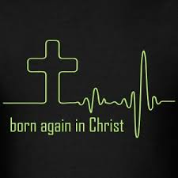THE NEW BIRTH

In the first lesson, we considered conversion – turning away from

the old, sinful life to God. It, therefore, speaks of what man has to do. Now, we

want to study the godly, divine side of a human being getting saved. God also

works through the Holy Spirit in those who turn to God. This is called "The

New Birth” in the Bible.

1. Before discussing the new birth in more detail, we must answer a fundamental question: Why must human beings be born again?

**Ephesians 2,1; Job 14:4**

______________________________________________________________________________________________________________________________________________________________________________________________________________________________________________________

Since all human beings are spiritually dead before God, they must have a new birth that enables them to come to God. The new birth is the work of the Holy Spirit – thus, the new birth is a work of God. It doesn't have to do with the physical birth but with a birth from above.

You can easily compare it with the day you were born: Natural birth makes us human beings and a child of our parents. The New Birth gives us a divine part and makes us a child of God.

1. The man Jesus said these words to was religious and pious. Was it still necessary for him to be born again – and thus for every other human being?

**John 3:3-7**

____________________________________________________________________________________________________________________________________________________________________

1. What right has been given to those who have received Jesus Christ (called here the Word), that is, to those who believe in his name?

**John 1:12**

__________________________________________________________________________________

1. What is the condition to be born again?

**1 John 5:1; John 1:12**

__________________________________________________________________________________

1. Of whom must we be born again?

**John 1:13; 1 Peter 1:3**

____________________________________________________________________________________________________________________________________________________________________

1. Read **John 3:5**. We must be born through the Holy Spirit's power–through the water's medium. It does not speak of natural water. So what is water here a picture of?

**1Peter 1:23; James 1:18; Ephesians 5:26**

______________________________________________________________________________________________________________________________________________________________________________________________________________________________________________________

1. What is the result of us being born of God (the Spirit)?

**John 3:6**

____________________________________________________________________________________________________________________________________________________________________

1. At the same time, the believer has a new birth. They begin a new life. There are some changes that the new life brings about. What are these?
2. **1 Peter 2:2, Matthew 4:4**

____________________________________________________________________________________________________________________________________________________________________

1. **1 John 2:29**

____________________________________________________________________________________________________________________________________________________________________

1. **1 John 4:7 and 5:1**

____________________________________________________________________________________________________________________________________________________________________

Through the new birth, we become part of God's family and can be sure of being sons/children of God (see John 1:12). Since sinners are entirely unable to ever come to God, we need to receive the gift of the new birth. The Holy Spirit causes it in us, which then takes place through applying the Word of God. This miracle is impossible to grasp fully – what we can and need to understand is the following: We must be born again by believing in the Lord Jesus Christ! This makes us part of God's heavenly family!

Yet, John 3:8 compares the process of the new birth with the wind: No one knows where it comes from or where it goes. It is a godly mystery, after all.

Finally, let us compare Conversion and New Birth. The Bible holds that there are two sides to salvation:

|  |  |
| --- | --- |
| CONVERSION | NEW BIRTH |
| The individual’s part in salvation (human side) | God’s part in salvation (divine side) |
| The individual must decide to turn to God | God gives a new life to those who believe |

Learning verse:

“Jesus answered: ‘Verily, verily, I say unto thee, Except a man be born of

water and the Spirit, he cannot enter into the kingdom of God.’”

*John 3:5*



Lesson3

BAPTISM

We have learned why and how someone can get saved. Faith is something in our hearts, and therefore, conversion takes place on the inside. Still, an action is being performed publicly – something that serves as a confession of what this person has done by turning to God. The Bible calls it “Baptism”. In this lesson, we want to learn what it is and why a true believer should get baptized.

1. When we read **Mark 16:16**, one could think that faith and baptism are necessary to be saved (and some churches teach that). But the last part of the verse tells us that only those who do not believe will be condemned.
2. Is baptism seen as a condition to be saved in**Romans 10:9.10?🡪**____________________
3. Read **Acts 10:44-48**. What happened first: believing or being baptized?

__________________________________________________________________

1. Read **Acts 8:35-38**. Did the Eunuch believe before or after Philip baptized him?

__________________________________________________________________

1. Did the robber on the cross have the chance to be baptized before he died and went to paradise together with the Lord Jesus?

**Luke 23:43🡪 _**____________________________________________________________

1. When believers get baptized, nothing changes through that action. It's merely a sign. What is the doctrinal meaning and purpose of water baptism?

**Romans 6:3-8; Colossians 2:12**

______________________________________________________________________________________________________________________________________________________________________________________________________________________________________________________

When someone gets saved by faith in the Lord Jesus Christ, they have accepted that they deserve the death penalty for their sins. This is that they somehow died with him at the cross. Baptism now symbolizes them having died and being buried with Christ.

Only genuine faith in the Lord Jesus Christ and His death on the cross makes us a child of God and saves us from eternal condemnation. We have seen that baptism isn't necessary to get saved. But baptism makes us a Christian publicly – through our public baptism, we claim (before the unbelievers) that we are dead and have new life through Jesus Christ (remember the New Birth). We are "officially" Christians, then. It does not bring us to heaven, but it makes us a follower of Christ in public. Even though 1 Peter 3:21 states that baptism saves us, it doesn't mean salvation in the sense of not getting to heaven. Salvation in the Bible has many different meanings. The meaning connected to baptism is "saved from an unbelieving world." Acts 2:40 says that the believers would be saved from a “perverse generation” – the baptism that would testify that someone just became a Christian would end all links to an unsaved world. Though saved for eternity, without baptism, we would still publicly belong to the world under judgment. Therefore, baptism saves in a way (not eternally, but publicly)!

1. Some characteristics of baptism
2. John the Baptist’s baptism (**Matthew 3:5.6**): What did the persons baptized by Him express with this action?

______________________________________________________________________________________________________________________________________________________________________________________________________________________________________________________

1. The Christian baptism (**Matthew 28:19**): What does it mean that God, the Lord Jesus, and the Holy Spirit are mentioned?

______________________________________________________________________________________________________________________________________________________________________________________________________________________________________________________

1. Discipleship (**Matthew 28:19**): What message do we send to the evil world when we get baptized?

______________________________________________________________________________________________________________________________________________________________________________________________________________________________________________________

1. Being on Christ’s side (**Acts 2:38**): What does it mean that one gets baptized "in the name of Jesus," the rejected and crucified man?

______________________________________________________________________________________________________________________________________________________________________________________________________________________________________________________

1. Died with Christ (**Romans 6:3.4**): Why is baptism essential concerning the fact that, in a way, Jesus did not die alone, but also my old man, my evil identity before my conversion, died with Him on the cross?

______________________________________________________________________________________________________________________________________________________________________________________________________________________________________________________

1. The plain meaning of baptism is that one is “baptized to” someone. This means to be joined to someone (to come into the same position), as **1 Corinthians 10:2** shows. What does **Acts 19:15** state concerning believers in this respect?

____________________________________________________________________________________________________________________________________________________________________

1. When being baptized, a believer publicly claims that they have died, were buried, and resurrected with Christ (**Romans 6:3-5; Colossians 3:1**). When getting out of the water, what are their responsibilities now?

**Colossians 3:1-4**

______________________________________________________________________________________________________________________________________________________________________________________________________________________________________________________

1. Through baptism, the believer states their death and burial with Christ on the cross. How should their life show the death and resurrection of the Lord Jesus Christ?

**Romans 6:9-14**

______________________________________________________________________________________________________________________________________________________________________________________________________________________________________________________

The plain outward action of being baptized resembles the inward change of that person.

Going into the water as a symbol of death speaks of the truth one has died with Jesus Christ, which has been realized at the conversion.

Are you already saved? If so, please allow me to ask you a personal question: Are you baptized? If you believe in the Lord Jesus Christ as your savior, it's not enough to do this in your heart. The Lord wants you to confess openly and publicly that you belong to Him and not the world anymore. It has to be manifested outwardly that you have inwardly parted from the world which crucified our Lord!

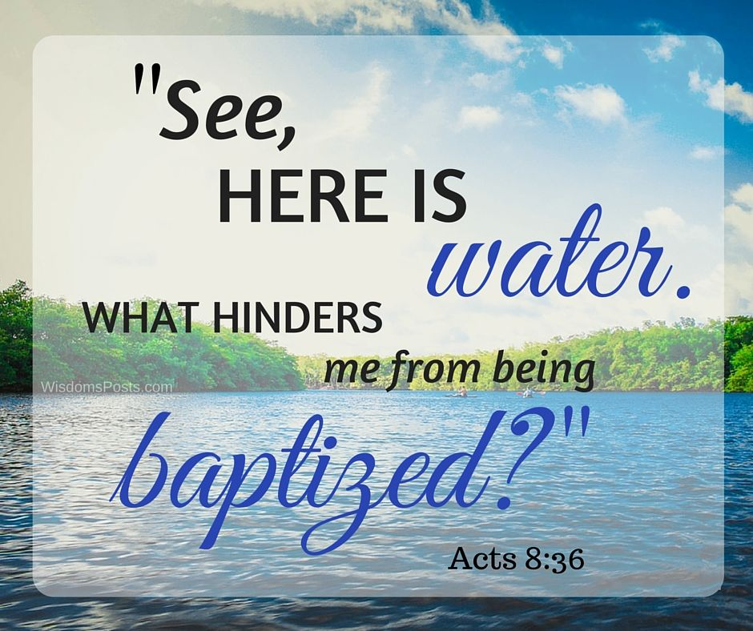



Lesson3

ASSURANCE OF SALVATION

Many true believers struggle with the question: “Am I saved forever – or can I lose my salvation and therefore get lost again?" “Assurance of Salvation” means the firm, inner confidence and certainty that a believer is God's child and, therefore, saved forever. Even though the Bible does not explicitly mention this Word, it provides some clear reasons why salvation is for eternity.

You might ask yourself why we have to consider this topic. But we will see how important it is to know if we are saved forever. Since the fear of getting lost again can be a great frustration and obstacle for Christians to rejoice in the Lord and His salvation, and since many churches teach different doctrines, it is a crucial subject for every Christian.

First, we want to consider reasons why salvation is forever. After that, we want to look at the practical consequences this has for believer's lives before we finally deal with difficult and often misinterpreted Bible verses that supposedly teach the opposite of what you will learn in this Bible course.

1. What is the promise of the Lord Jesus to those who are saved?

**John 10:28**

____________________________________________________________________________________________________________________________________________________________________

1. All human beings without Jesus Christ will be condemned. What is the promise concerning believers?

**Romans 8:1**

____________________________________________________________________________________________________________________________________________________________________

1. How far do the Old Testament verses show us that God will never make those accountable who believe in Him?

**Psalms 103:12; Isaiah 38:17**

____________________________________________________________________________________________________________________________________________________________________

1. Jesus Himself speaks about the duration of salvation's "validity." What does He say?

**John 3:16 and 3:36**

____________________________________________________________________________________________________________________________________________________________________

1. God desires a sinless life with every believer. But yet, they often fall into temptation and commit sins. We have seen that there is no way a genuine Christian can lose salvation – even not through sinning again. Thus, by implication, the knowledge of being saved cannot come through a "perfect" life without sin. No Christian would claim never to sin anymore. When the inner confidence of a believer that they will be God’s child forever does not come from a perfect life – how else can it be achieved?

**Romans 8:15; Galatians 4:6**

____________________________________________________________________________________________________________________________________________________________________

1. In **Romans 8:31-39**, we find God's declaration of love towards us. And therefore, it is like proof for someone who has believed in Jesus Christ and received forgiveness of sins. For example, in **verse 31**, we learn that God is for us, not against us. What did God give to prove He is for and loves us (**verse 32**)?

____________________________________________________________________________________________________________________________________________________

1. **Verses 31, 33, 34, and 35** contain rhetorical questions. "Who can be against us?" The answer is "Nobody" because God is for us. "Who shall bring a charge against God's elect?" Again, the answer is "Nobody" because God justifies us. "Who is he who condemns?" Again, the answer is "Nobody" because Christ died for us and took our punishment. "Who shall separate us from the love of Christ?" The answer is "Nothing"!
2. What is Jesus Christ doing for us at the right hand of God (**verse 34**)?

__________________________________________________________________________________

1. Please list everything that can not separate us from the love of Christ (**verse 35**).

__________________________________________________________________________________

1. Please list everything that can not separate us from the love of God (**verses 38-39**).

____________________________________________________________________________________________________________________________________________________________________

1. The assurance of salvation can be misused, say some. What about the argument that – if there was assurance of salvation – a believer could sin without a limit as they would have nothing to fear?

**Romans 6:1.2; Galatians 5:13**

____________________________________________________________________________________________________________________________________________________________________

When you are saved, you still might be scared by doubts questioning the assurance of salvation. One of them is: "I don't feel saved. Thus, I can't be saved!"

Answer: It's not essential to have an emotional feeling. Many verses talk about the knowledge we as Christians can have (Romans 6:9 and 8:28, 2 Corinthians 4:14, Galatians 2:16, 1 John 3:2, etc.). Read John 5:12+13. John does not write “that you may feel that you have eternal life” and even less "that you may work so that you have eternal life," but he writes "that you may know that you have eternal life"! Assurance of faith is not so much an emotion you can feel, but it is a truth that we know because the Bible tells us so. And when we believe that Jesus Christ died for our sins at the cross, we can also put our trust in the Word of God, which wants to give us the assurance of salvation when we are born again.

Additionally, we find more reasons in the Bible why salvation is there forever. In the following lessons, we want to study some of them.

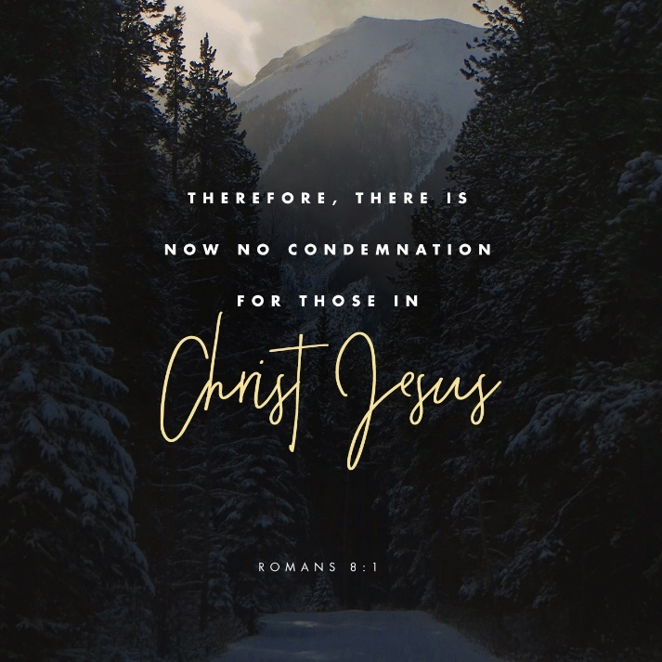



Lesson4

ASSURANCE OF SALVATION – REASON 1

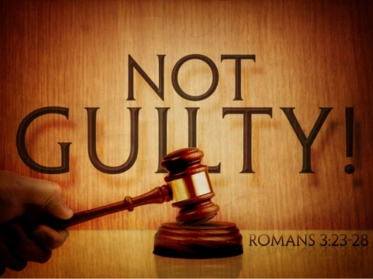Justification nowadays, in legal and judicial terms, means an acquittal. Someone gets absolved as there wasn't enough proof for the judge to pronounce him guilty. Justification in the biblical sense means more: God as the judge doesn’t acquit those who trust Jesus Christ as their Saviour because of lack of proof and declares that they have no charge of sin against them – Jesus’ death and the cross enables God to do this. Why? Because his Son received the full punishment for those sins when he was crucified. True believers appear before God as if they had never committed any sin. Thus, it is not a pardon or amnesty but rather an absolution due to a lack of evidence. This is justification – a gift from God.

1. How can God justify someone?

**Romans 3:28**

____________________________________________________________________________________________________________________________________________________________________

1. Can we do anything by ourselves to earn God's justification?
2. **Romans 3:24**

____________________________________________________________________________________________________________________________________________________________________

1. **Galatians 2:16**

____________________________________________________________________________________________________________________________________________________________________

1. Another Scripture explains salvation by describing the price paid to save the believers. What price had to be paid to justify them? Who paid the price?

**Romans 5:9**

____________________________________________________________________________________________________________________________________________________________________

1. What are the great results of our justification?
2. **John 5:24**

____________________________________________________________________________________________________________________________________________________________________

1. **Romans 8:1**

____________________________________________________________________________________________________________________________________________________________________

1. The devil, as the accuser of the believers (Revelation 12:10), wants to bring charges against them to hold against them their sins. What is God's answer?
2. **Romans 8:33.34**

____________________________________________________________________________________________________________________________________________________________________

1. **Hebrews 10:14**

____________________________________________________________________________________________________________________________________________________________________

God can justify us through faith in Jesus Christ and his death on the cross. This means that we can be cleared from every charge of guilt. God then views us as in a righteous condition. It surpasses our understanding of God’s grace to regard terrible sinners as those who have never committed any sin. Why is that important?

When someone has done something wrong against their friend, this friend can forgive the wrong that was done, but they can not declare the wrongdoer. It is only possible to justify someone (say that he is righteous) when he is falsely accused. Human beings never were falsely accused of God – but with the justification from the Lord Jesus, believers are before God as if they were guiltless. Of course, they are not – but the blood of Jesus makes them appear like that!

And that’s just possible through Jesus Christ! Believe in him!



Lesson5

ASSURANCE OF SALVATION – REASONS 2-8

We have already discussed many verses that can reassure a believer that they will never lose salvation. Finally, we want to consider seven more reasons.

Reason 2: remission/forgiveness of sins

The sheer endless and innumerable sins we committed had to be forgiven.

1. When we forgive each other for something, we still won't be able to forget. How does God deal with the sins of those who earnestly confess and repent?

**Isaiah 38:17; Psalm 103:12; Jeremiah 31:34 (last part of the verse); Micah 7:19**

____________________________________________________________________________________________________________________________________________________________________

1. Some believers are afraid they might have forgotten some sins when they confessed. How many sins has God forgiven?

**Colossians 2:13; 1 John 1:7+9**

__________________________________________________________________________________

1. For how long is this remission valid?

**Hebrews 10:14**

__________________________________________________________________________________

Reason 3: redemption

As unbelievers, we were in many different bondages and subjugations.

1. Name the various bondages that believers got redeemed from.

|  |  |
| --- | --- |
| Bible verse | bondage |
| **Romans 8:3** |  |
| **Hebrews 2:14+15** |  |
| **Galatians 3:13** |  |
| **Romans 8:21** |  |

1. What is the great price that had to be paid to redeem us?

**Hebrews 9:12; 1 Peter 1:18+19**

__________________________________________________________________________________

1. It is clear, as the Epistle to the Hebrews, for example, claims often that the Lord Jesus only died once because the worth of His precious blood is endless. How long, therefore, is this redemption based on His blood valid?

__________________________________________________________________________________

Reason 4: reconciliation

Only those who are in enmity with somebody need reconciliation. What were we enemies of, and how did we get reconciled?

**Romans 5:10; Colossians 1:20-22**

__________________________________________________________________________________

__________________________________________________________________________________

In the biblical sense, reconciliation means recovering a lost relationship. However, it is essential to comprehend that we were God's enemies (through our sins against Him), but He was NOT our enemy. The relationship was destroyed one-sidedly.

Thus, through the work of the Lord Jesus, believers are brought into a beautiful relationship with God—not only recovering the relationship before but becoming children of God. It is impossible to imagine that this reconciliation could be changed again.

Reason 5: God’s plan

1. Can the fulfillment of God’s plan ever be prevented?

**Isaiah 46:10**

_________________________________________________________________________________

1. Will God change His plans?

**Malachi 3:6; James 1:17**

_________________________________________________________________________________

1. The Bible says that we were saved due to God’s plan (**2 Thessalonians 2:13; 2 Timothy 1:9**). Based on answers a) and b): Is there any chance that we lose our salvation, which is according to His plan? _________________________________________________________________

Reason 6: New Birth and Children of God

We have already considered the new birth. It gives the believer a new, heavenly nature (he is born again) and makes them part of God’s family. Even if you sinned much against your parents and dishonored them so much that they would disown and disinherit you – would you remain their child? _____________________________

Apply your answer to God. Is it possible that we can lose our position as Children of God? __________

Reason 7: Being made alive

1. Why was it necessary to be made alive?

**Ephesians 2:5; Colossians 2:13**

__________________________________________________________________________________

1. How long will believers keep this new life, according to the Lord Jesus Himself?

**John 3:16; John 5:24**

__________________________________________________________________________________

Reason 8: The indwelling of the Holy Spirit

We have already seen that the Holy Spirit dwells in every true believer; at that moment, someone gets saved. According to **Ephesians 1:13+14**, the Holy Spirit guarantees the inheritance – inheritance here speaks of everything believers will have in heaven one day.

1. If the Holy Spirit guarantees them their future in heaven, can that guarantee be taken away, and God thus be called a liar? ____________________________________________________
2. What does the Bible say about the duration of the Holy Spirit being with the believers?

**John 14:16**

__________________________________________________________________________________

Summary

After considering the Bible verses concerning the assurance of salvation, conclude: is salvation forever, or can a true believer lose it again? __________________________________________________

|  |
| --- |
|  |
|  |  |

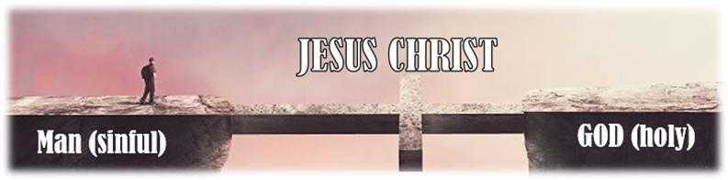

Lesson6

WHAT ABOUT DIFFICULT VERSES?

This time, we want to deal with some verses about the assurance of salvation that may be difficult to understand. You may think that these verses mean that a Christian who is born again can get lost. But when we look closer at them, we will see that their meaning is obvious and that there are no contradictions in God's Word!

Bible passages (please read all before answering the questions):

**2 Peter 1:20; Psalm 51:11; Matthew 24:13; 1 Timothy 4:1; John 15:1-8; Hebrews 6:4-9; Hebrews 10:38.39; 1 John 5:4.5.16**

1. **2 Peter 1:20** is a significant verse, not only for this topic but for every topic in the Bible! What do we need to know?

____________________________________________________________________________________________________________________________________________________________________

No verse in the Bible can be explained and interpreted without also taking into account other verses. For example, The Bible clearly says that someone born again cannot get lost. Thus, if we read verses that seem to say something different, we must look at the context in which these Scriptures are written. Once again, It is impossible that the Bible says in one verse that the salvation of a genuine believer is secure but states the opposite in the next verse!

1. **Psalm 51:11** is the first verse we want to examine: "Do not cast me away from your presence and do not take your Holy Spirit from me." Who wrote this Psalm (look at the beginning)?

__________________________________________________________________________________

1. Today, the Holy Spirit dwells in every Christian born again forever. Was this also true for a believer in the Old Testament (Abraham, Moses, David, etc.)?

__________________________________________________________________________________

In the Old Testament, we must consider that the verses were written when believers did not yet possess the Holy Spirit living (dwelling) in them. This means that verses from the Old Testament do not(!) prove that a believer can get lost again because the believers in the Old Testament did not have the assurance of their salvation – in contrast to believers today! A similar Scripture is **Matthew 24:13**. The whole passage from **Matthew 24:1-44** talks about a future time when the Jews will be awfully persecuted. In this time, those Jews who will endure until the end will be saved. But this scripture does not talk about Christians!

1. Some say that **1 Timothy 4:1** proves a believer can "depart from the faith." But this is not true. Some people only profess that they have faith in Jesus Christ, although they do not have faith. The "best" example is Judas Iscariot. The disciples thought that he had faith, too. But they were wrong; Judas was not born again; he was only a professor. How does the Lord Jesus call him in the following Scriptures?
2. **John 6:70**: ___________________________________________________________
3. **John 17:12**: __________________________________________________________

Remember: Judas Iscariot has never been a believer; he only pretended to be an upright disciple of the Lord Jesus, but he was not born again!

1. In **John 15:1-8**, we find an illustration of a true disciple (e.g., Peter) and a false disciple (e.g., Judas Iscariot): the parable of the true vine. According to some Christians, it supposedly shows that a believer who does not produce fruit and does not abide (=remain) in Jesus Christ will be cut off and can get lost. But what does the Lord Jesus say in **verse 2**? Tick the correct answer.

“Every branch that does not bear fruit He takes away.”

“Every branch that does not bear fruit anymore He takes away.”

Please note that this passage talks about the responsibility of those who profess to be Christians (disciples). But not everyone who professes to be a Christian is born again. It does not say that once they produced fruit, and now they stopped producing fruit. No, those not born again can never produce fruit and won't abide (=remain) in the Lord Jesus (**verse 6**). That means that they (=those who are not born again) will be cut off and be thrown into the fire because they did never accept Jesus Christ as their personal Saviour, and they were not born again. But this does not touch the eternal security of a true believer!

1. Let us turn to **Hebrews 6:4-9**. What were the characteristics of those who could not be renewed to repentance (see **verses 4 and 5**)?
2. They were once _______________________________________________________
3. 🡪 This is not the same as being “light in the Lord” (**Ephesians 5:8**).
4. They have tasted ______________________________________________________
5. 🡪 This is not the same as “eating the flesh of the Son of Man and drinking His blood” (**John 6:53**).
6. They have become ____________________________________________________
7. 🡪 This is not the same as being “born of the Spirit” (**John 3:8**).
8. They have tasted the ___________________________________________________ and the ______________________________________________________________

* These people belong to those who know the Word of God, but it was not “mixed with faith” (**Hebrews 4:2**). They have done great works in the name of the Lord (**Matthew 7:21-23**). But: This is not the same as “hearing the word, accepting it, and bearing fruit” (**Mark 4:14-20**). Those persons were never saved!

1. What was the conviction of the writer of this Epistle regarding the true believers among the Hebrews (**verse 9**)?

____________________________________________________________________________________________________________________________________________________________________

1. Read again **Hebrews 10:38-39** and fill in the missing words: "Now ____________________ shall live by ____________________; but if ____________________ draws back, my soul has no ______________________ in him." Note the difference: The first part speaks about the righteous one, and the second part talks about anyone who is not a true believer!
2. To which group of people do those belong who are born again (**verse 39**)?

__________________________________________________________________________________

We must remember that the Epistle to the Hebrews was written to Jews who had become Christians. But some only outwardly professed to be Christians because of wonderful miracles happening there. But when persecution arose, they turned back to Judaism. The writer of the Epistle to the Hebrews warns them against falling away (departing) from God. Those who fall away are described as those who have "an evil heart of unbelief" (Hebrews 3:12). This is only true for unbelieving professors, and this cannot be said about a true believer who is born again!

1. Several scriptures in the Bible encourage us to overcome (e.g., **Revelation 2:11; 3:5; 21:7**). This makes some true believers think they might get lost if they are weak in faith or not faithful. But what are the characteristics of those who overcome the world?

**1 John 5:4**

____________________________________________________________________________________________________________________________________________________________________

1. What is the victory that has overcome the world?

__________________________________________________________________________________

1. Who overcomes the world (**1 John 5:5**)?

____________________________________________________________________________________________________________________________________________________________________

This shows that you are not an overcomer because you are a powerful, faithful, good, devout Christian. According to the Word of God, everyone who believes in Jesus Christ as his personal Saviour is born of God and is an overcomer.

1. In the same chapter, we find a special kind of sin in the life of a true believer (=someone who is born again!). How is this kind of sin called in the last part of verse **1, John 5:16**?

__________________________________________________________________________________

1. We find two kinds of death in the Bible: physical death (=of the body) and spiritual death (=separation from God). We learned that a true believer can't get lost after he is born again. Thus, Can a true believer be separated from God (=suffer spiritual death)?

__________________________________________________________________________________

1. So, which kind of death is meant here in **1 John 5:16**? Physical death or spiritual death?

__________________________________________________________________________________

In extraordinary occasions (not always!), God uses physical death as a discipline for a Christian because of a severe sin. John, the Apostle, didn't want us to doubt the eternal security of a born-again believer. He wrote his Epistle "that you may know that you have eternal life" (verse 13). Of course, this is only true for someone who is born again and not for someone who only professes to be a Christian!

There are probably more scriptures that may cause some doubts regarding the assurance of salvation. If any further questions arise, feel free to ask us.



Lesson7

GRACE AND RESPONSIBILITY

Now, we want to discuss a critical topic that has caused much confusion in Christianity: grace and responsibility. Distinguishing between grace and responsibility is decisive for a good understanding of the Bible, especially when discussing the assurance of salvation.

Bible passages (please read all before answering the questions):

**Romans 3:24+28; Ephesians 2:8-9; Romans 5:20; Romans 6:1-2+14-15; Romans 8:13; James 2:17+22+24+26; 1 Corinthians 3:14-15**

1. Reread **Romans 3:24 and Ephesians 2:8**. On which foundation is a believer justified?

__________________________________________________________________________________

1. Look at **Romans 3:28 and Ephesians 2:9**. How can someone obtain this justification?

__________________________________________________________________________________

1. Accordingly, can we add any good works to be justified before God?

_______________________________________________________________________

1. Let us turn to **Romans 5:20**. What is greater: our sin or the grace of God?

_______________________________________________________________________

Some people might say, "If grace abounds even more when I sin, then it will be good to sin." But this would mean that we turn God's grace into excess and use it to do bad things (sins), which is obviously against God (**Jude 1:4**).

1. Answer the question in **Romans 6:1**: “Shall we continue in sin that grace may abound?”.

__________________________________________________________________________________

1. See **verse 2**. How does the apostle Paul describe the relationship of a believer towards sin?

__________________________________________________________________________________

1. Read **verses 14-15** in the same chapter again and answer the question: "Shall we sin because we are not under law but under grace?”.

_______________________________________________________________________

1. What happens if we continue to live in sin? What will then have dominion over us?

_______________________________________________________________________

Therefore, we see that we are saved by grace through faith, not by works. We already saw in the previous study that we are saved forever when we are born again. But this does not mean that we can just continue sinning. Sinning is opposite to the new nature of a born-again Christian. Therefore, our behavior should correspond to our nature. There is no verse in the Bible that says that we can get lost after being saved, nor is there a verse saying that a believer can continue to sin. Quite the contrary: The will of God for believers is their sanctification (1 Thessalonians 4:3)!

Maybe you think that **James 2:24** says that "a man is justified by works, and not by faith only ."And you are right! But it is essential to mark the difference between **Romans 3:28** and **James 2:24**!

1. How does James describe someone who professes to have faith but does not have works? **James 2:17**

__________________________________________________________________________________

1. **Verse 21** shows that Abraham proved his faith by offering his Son Isaac. How was Abraham's faith made perfect?

__________________________________________________________________________________

1. This is a fundamental teaching for us! If you profess that you have faith, how can you prove your faith towards other people?

____________________________________________________________________________________________________________________________________________________________________

1. Which comparison is used in **verse 26** to describe that faith without works is dead?

__________________________________________________________________________________

The Book of Romans discusses our relationship with God, but the Epistle of James discusses our relationship with others. With regard to God, we are justified only by faith because God can see our hearts, and He does not need works to see our faith. However, with regard to other people, we need works that prove our faith!

1. Finally, we want to have a look at **1 Corinthians 3:14-15**. What will a believer receive in the future if their works will endure (i.e., when the works were honoring God)?

__________________________________________________________________________________

1. If the works of a believer will be burnt because they were useless to God, they will suffer loss because this person will not receive a reward. But what will happen to this person if they are born again?

____________________________________________________________________________________________________________________________________________________________________

Also, these verses show that a true believer cannot get lost, although his works were not valuable to God. Nevertheless, this believer will suffer the loss of their reward. This displays the truth of grace and responsibility: Grace because this believer will be saved; responsibility because he will not receive a reward for his works.